ACCESSING SCHOOL/WORK EMAIL FROM
HOME OR A NON-WORK LOCATION

Email is often used to share information with faculty/staff. There are several ways to access school/work email from home, or a non-work location. Below please find more information on how to access your school/work email when you are not at work. Please note this can be used on any device that has access to the Internet, including cell/mobile phones.

ACCESSING SCHOOL/WORK EMAIL FROM HOME BY USING AN INTERNET BROWSER
- Launch an Internet browser – most common Internet browsers are shown below.
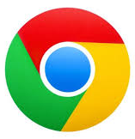
Edge/Microsoft Edge
Chrome/Google Chrome

Internet Explorer
Firefox/Mozilla Firefox

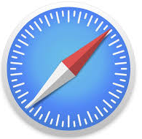
Safari (Mac, iPad, iPhone)

- In the address bar at the top of the screen, type in the following:
myapps.hancock.stier.org
and press/click Enter on your keyboard
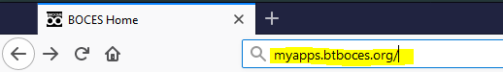

- You will land on the page shown below. In the Email Address box, type in your school/work email address. Your email address is typically the first letter of your first name followed by the first seven letters of your last name @hancock.stier.org – it is the same user name used to login the computer when at school/work.
Example: John Williams would use: jwilliam@hancock.stier.org
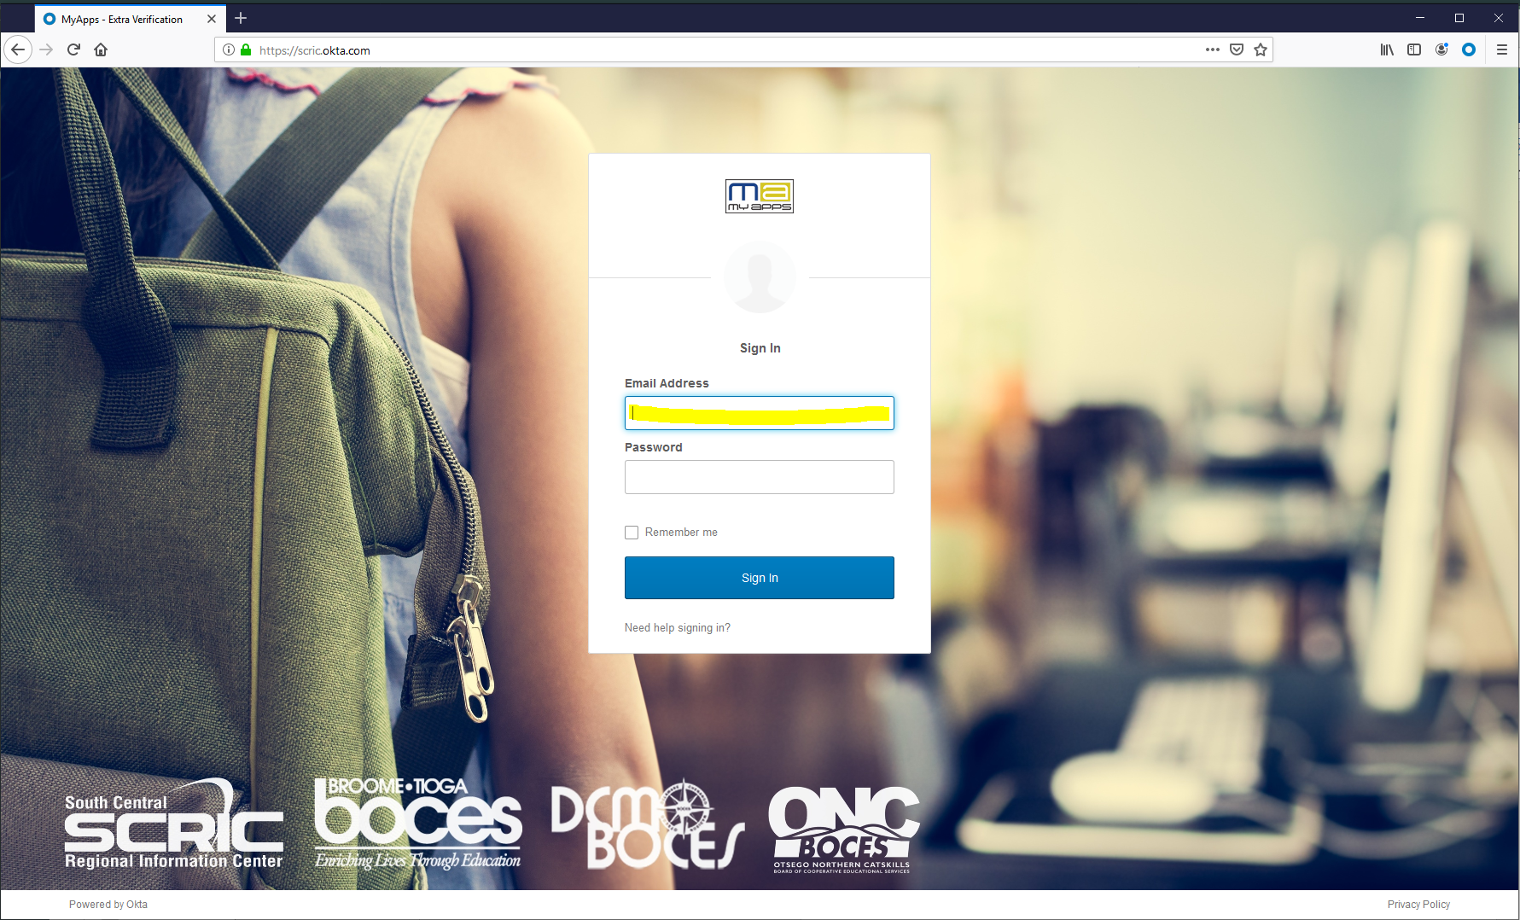

- In the password box, enter your password. It is the same password used to login to the computer when at school/work. If you do not know your password, please call 607-766-3800 and a service desk representative will assist you
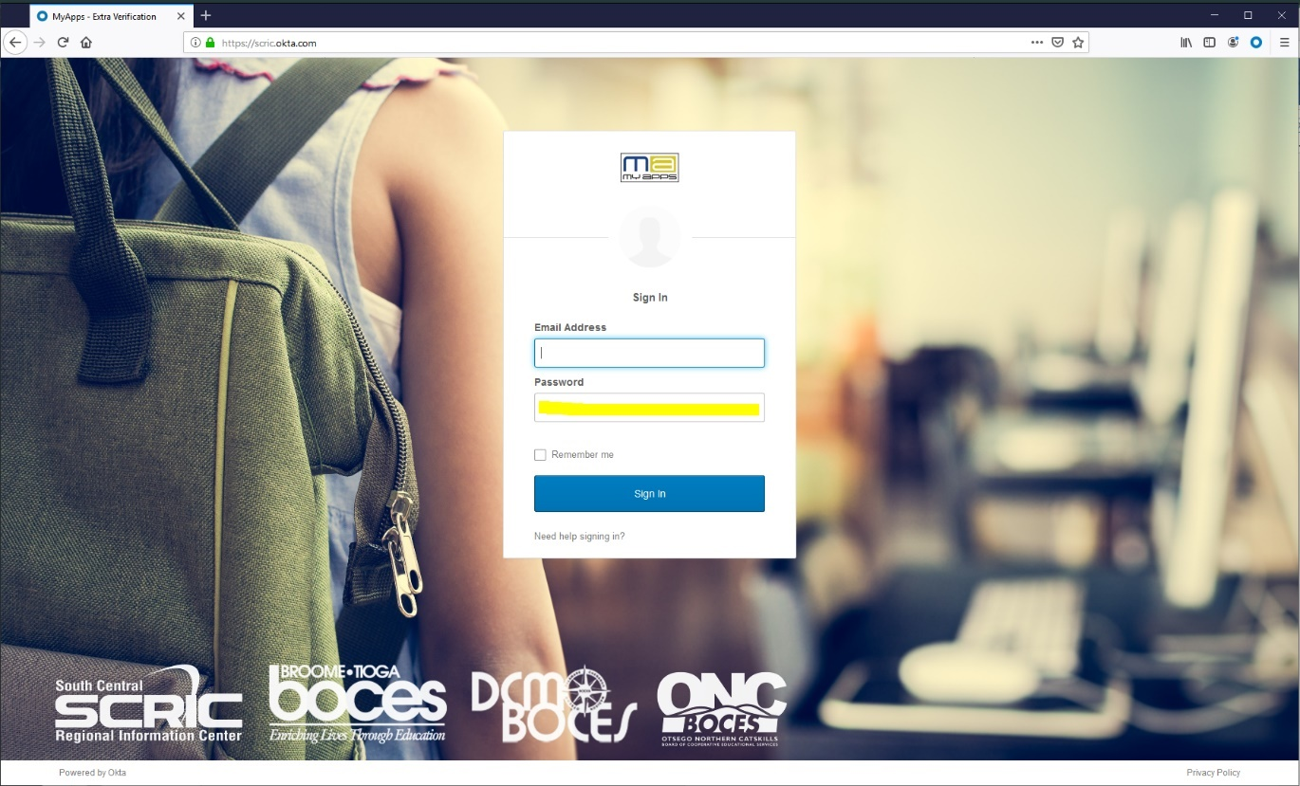

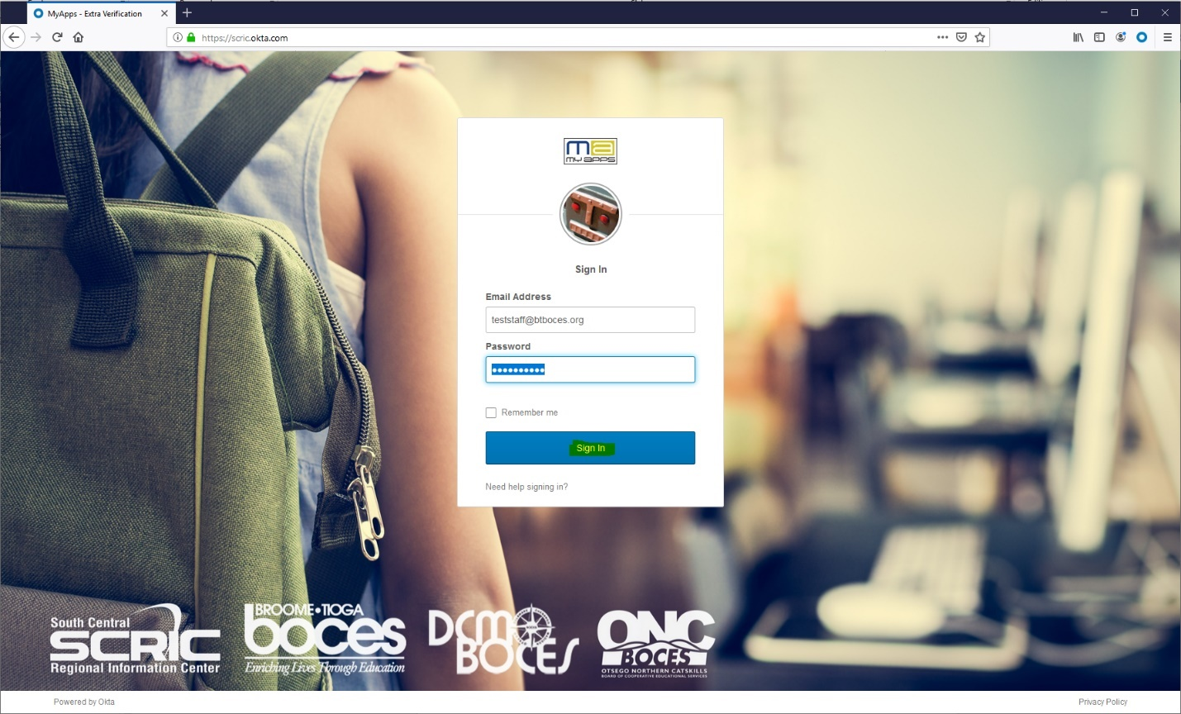
- Once you enter your email address and password, click the blue Sign In button
- If this is your first time signing in, you may see the screen below. If you do not see the screen below, please skip to step 8.

- The screen below allows you to set-up the ability to reset your password on your own in the future (known as password self-service reset). There are two options for setting up password self-service reset:
  - Option 1: using a secondary email address (ex: personal email address like Gmail, Yahoo, etc.)
  - Option 2: using a cell/mobile phone number
Note: You can skip this process by clicking the Create My Account button in the bottom right-hand corner of the screen.
This is optional: To use a secondary email address for password self-service reset, make sure the secondary email button is selected and enter your secondary email address. Note: you will receive an email from MyApps Notification to confirm your email address – click here for more information

If you use a secondary email address or cell/phone number, this is required. Next select an option from the dropdown Choose a forgot password question and enter an answer for the question

This is optional: To use a cell/mobile phone number, click the button Add Phone Number. A pop-up box will open for you to enter your cell/mobile phone number. Click on Send Code. Enter the code that is sent to your cell/mobile phone and click Verify. Once successful, click Done

If you use a secondary email address or cell/phone number, this is required. Click on an image (when you see this image, you know you are logging into our website).

Click the button Create My Account

- You will see an image similar to the one below. To access your email, click on BTBOCES Office 365 Mail icon.

- An additional browser tab will open that contains your email similar to the image shown below.

- Click on a message to read it. Please note you may have messages that appear in a couple of different locations. In the image below, there are messages in Focused and messages in Other. Please make sure to click each one so you can see all of your messages.
Note: exercise caution before clicking on/reading emails. Please be aware that phishing emails may look like they are from a company you know or trust.
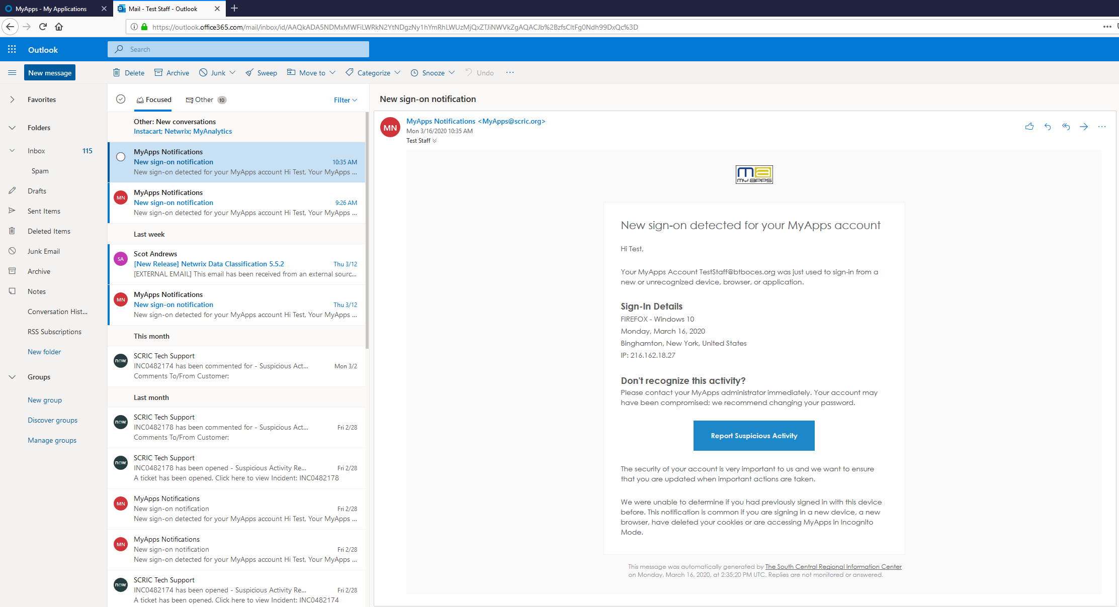

- To close your email, click the browser tab for your email only as shown in the image below.

- This will take you to the MyApps portal. In the upper right-hand corner, click the dropdown arrow by your user name and select Sign out. This ensures you are logged out.

CONFIRMING YOUR SECONDARY EMAIL ADDRESS
- Once you have set-up a secondary email address for self-service password reset, an email notification from MyApps Notifications <MyApps@scric.org> will be sent to that account. It will look similar to the message shown below.
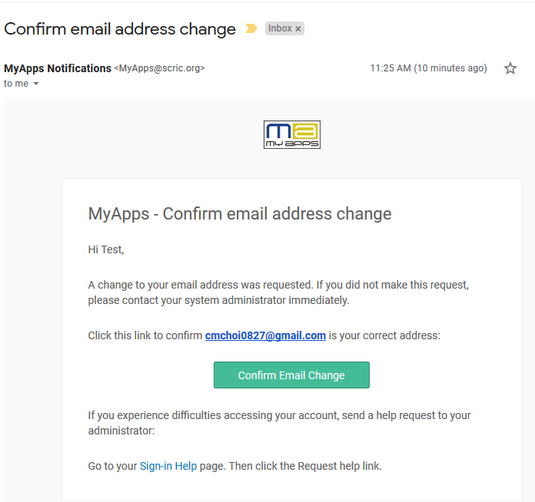

- To finish the self-service password reset process, click on the button Confirm Email Change. Please note this link expires in 16 hours

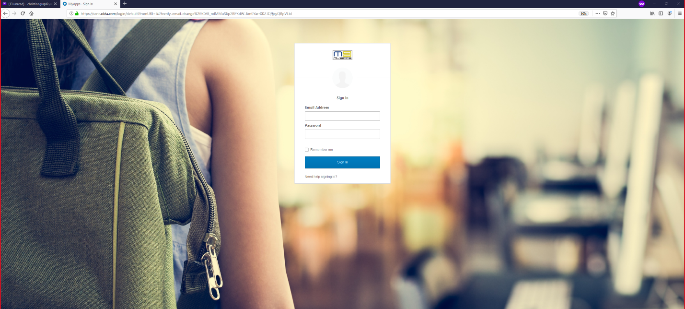
- You will then be directed to the initial login page similar to the image below. Please enter your email address and password

- You will receive a message similar to the one below once you sign in. This confirms you have completed the self-service password reset process using your secondary email.

EMAIL ALERTS WHEN ACCESSING EMAIL FROM HOME OR A NON-WORK LOCATION

- Each time your account is accessed on a new device, you will receive an email notification from MyApps Notifications <MyApps@scric.org> to your school account similar to the message shown below. If you used a secondary email when you created your account, you will receive a similar email notification to that account. It will look similar to the message shown below.
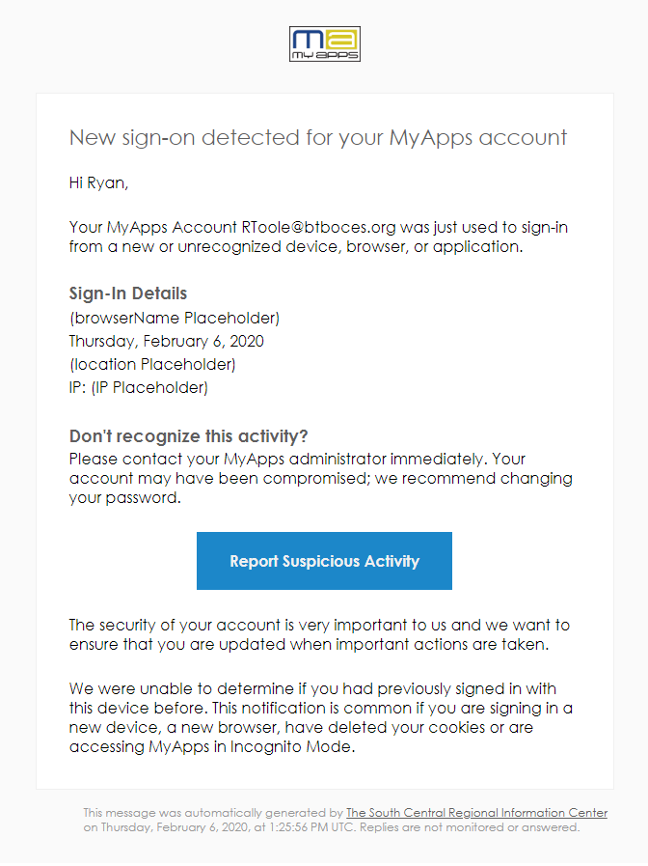

- If you did login to a new device for the first time, you can ignore the email and delete it. If you did not login to your account, click the Report Suspicious Activity button in the email message
- When you click the Report Suspicious Activity button, a ticket will be opened notifying the service desk representatives. A representative will reach out to you to review the account access and confirm if there is an issue or not.

